WHATNEXT VISION MOTORS: SHAPING THE FUTURE OF MOBILITY WITH INNOVATION AND EXCELLENCE

SALESFORCE PROJECT REPORT
Submitted by

PRANESH KUMAR M | 412723243038
DINESH P L | 412723243017
VENKADESH P | 412723243053
VENKATESH M | 412723243054

BACHELOR OF TECHNOLOGY

in

ARTIFICIAL INTELLIGENCE AND DATA SCIENCE


TAGORE ENGINEERING COLLEGE, RATHINAMANGALAM, CHENNAI – 600 127

WhatNext Vision Motors: Shaping the Future of Mobility with Innovation and Excellence

ABSTRACT
WhatsNext Vision Motors is undertaking a transformative Salesforce CRM implementation aimed at enhancing customer experience and operational efficiency within the automotive sector. Central to the solution is a data model integrating vehicle inventory, dealer locations, and customer management. The CRM leverages automated workflows and Apex triggers to enforce business logic—blocking orders for out-of-stock vehicles and auto-assigning new orders to the nearest dealer based on customer geolocation.
Complementing these real-time safeguards, the project integrates scheduled processes: batch Apex updates stock availability across bulk orders and scheduled Apex dispatches email reminders for test drives and stock replenishment. Together, these components form a cohesive system that offers transparent, accurate order tracking—marking statuses as “Pending” or “Confirmed” depending on inventory levels.
The technical implementation includes structured data modeling of vehicle and dealer records, Lightning App Builder for streamlined UI interactions, record-triggered flows for dynamic logic execution, and robust Apex code for validation and automation. By reducing manual intervention, minimizing customer friction, and improving responsiveness to stock changes, the project is set to significantly elevate customer satisfaction and internal productivity— propelling WhatsNext Vision Motors toward more agile and customer-centric operations.

OBJECTIVE
The objective of this project is to enhance the customer ordering experience by leveraging Salesforce automation and intelligent data handling. It aims to streamline dealer assignment, ensure real-time stock validation, and provide accurate order status updates. By doing so, WhatsNext Vision Motors seeks to improve customer satisfaction and operational efficiency across its mobility services.
- Enhanced Customer Experience: Simplifying the ordering process with automated dealer suggestions and real-time updates.
- Real-Time Stock Management: Preventing out-of-stock orders through accurate inventory validation.
- Automated Dealer Assignment: Assigning orders to the nearest dealer based on customer location.
- Efficient Order Processing: Using scheduled processes to update order statuses and streamline fulfillment.
- Smart Salesforce Integration: Implementing Apex, Flows, and Batch Jobs to automate and scale operations.

TECHNOLOGY DESCRIPTION

Salesforce:-
Salesforce is a cloud-based Customer Relationship Management (CRM) platform that enables businesses to manage customer interactions, data, and processes efficiently. In this project, it is used to store and manage vehicle details, dealer locations, and customer orders. The platform supports automation through Flows, Apex triggers, and batch jobs to ensure accurate stock validation and smart dealer assignment. By leveraging Salesforce, WhatsNext Vision Motors enhances operational efficiency and delivers a seamless, customer-centric ordering experience.

Custom Objects:-
Objects in salesforce are like tables in a database. Custom Objects are created to store specific data. Example:
- Vehiclec - Stores vehicle details
- Vehicle_Dealerc- Stores authorized dealer info
- Vehicle_Customerc- Stores customer details
- Vehicle_Orderc- Tracks vehicle purchases
- Vehicle_Test_Drivec- Tracks test drive bookings
- Vehicle_Service_Requestc- Tracks vehicle servicing requests

Tabs:-
Tabs are used to display data in the Salesforce UI
Example: A tab for vehicle_c allows users to easily view, create, and manage vehicle

Custom APP:-
An App in Salesforce is a collection of tabs grouped together for a specific business purpose, allowing users to access related data and functionality in one place.

Fields:-
A fields in Salesforce is a specific piece of data stored in an object, much like a column in a spreadsheet. Each field holds a particular type of information such as text, date, number, or picklist values.
Example: Vehicle_Modelc – A Picklist field in the Vehiclec object with options like Sedan, SUV, EV, etc.

Flows:-
Flows automate business logic without writing code. They can create or update records, and send notifications automatically.
Example:-
- A flow triggers an email alert whenever a new order is created.

Apex:-
Apex is Salesforce’s Object-Oriented programming language. It allows developers to write custom logic .
Example Triggers:
- A trigger automatically validates stock availability when a new vehicle order is created.
- It prevents orders if the vehicle is out of stock.
- Once the order is confirmed, the trigger updates the stock quantity by reducing it.
DETAILED EXECUTION OF PROJECT PHASES

Developer Org Setup
  - A Salesforce Developer Org was Created Using https://developer.salesforce.com/signup
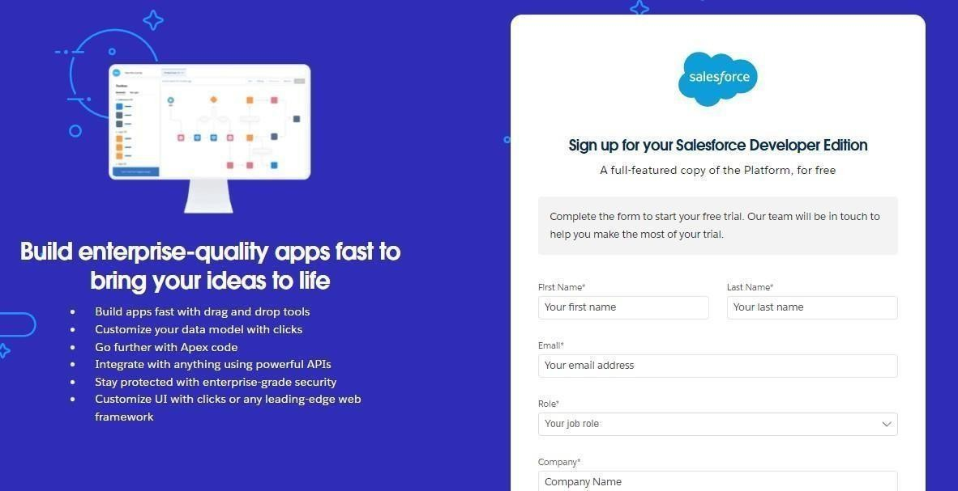

  - The account was verified, password set , and access was granted to the Salesforce Setup page.

Custom Object Creation
Six Custom Objects were created to store business-critical data

  - Vehicle – Stores vehicle details like model, stock, price, and status.
  - Vehicle Dealer – Contains information about dealers such as location and contact details.
  - Vehicle Order – Tracks customer orders, order dates, and order status.
  - Vehicle Customer – Maintains customer details including contact and preferred vehicle type.
  - Vehicle Test Drive – Records test drive schedules and status.
  - Vehicle Service Request – Logs service requests, dates, issues, and progress status.

Steps followed:
  - Navigated to Setup → Object Manager → Create → Custom Object.
  - Provided Label, Name, and enabled options for Reports and Search.
  - Saved and created Tabs for each object.
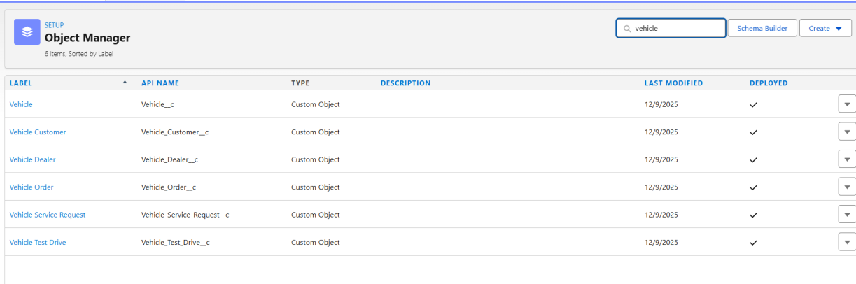

Creating a Custom Tab

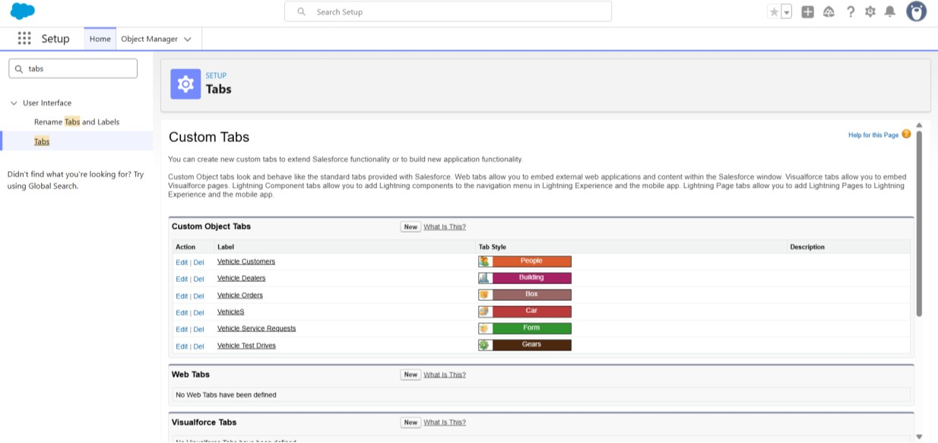

- Creating the Lighting App
  - A custom Lightning App named WhatNext Vision Motors was created.
  - Included tabs: Vehicle, Vehicle Dealer, Vehicle Order, Vehicle Customer, Vehicle Test Drive, Vehicle Service
  - Assigned to the System Administrator profile.

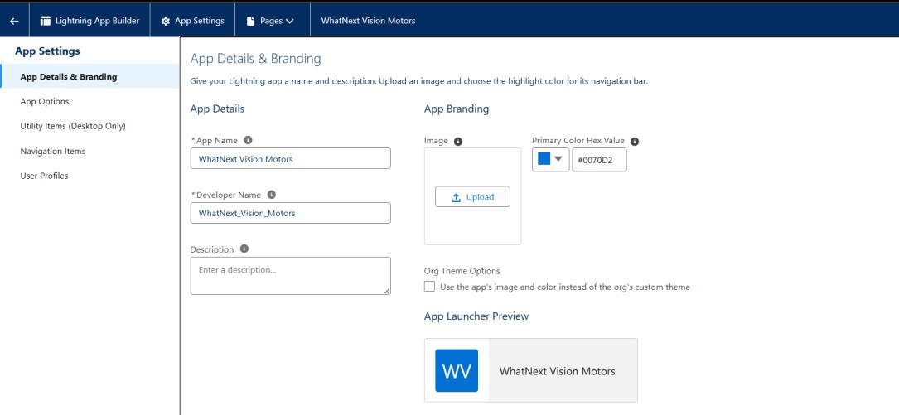

Creating Fields
Custom fields were created on each object to store specific business data.
For example, on the Vehiclec object, a Picklist field named Vehicle_Modelc was created with values like Sedan, SUV, and EV.

Steps followed:
  - Navigated to Setup → Object Manager → [Object Name] → Fields & Relationships → New.
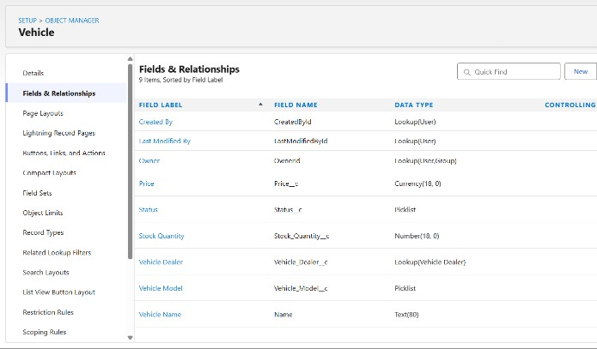 | 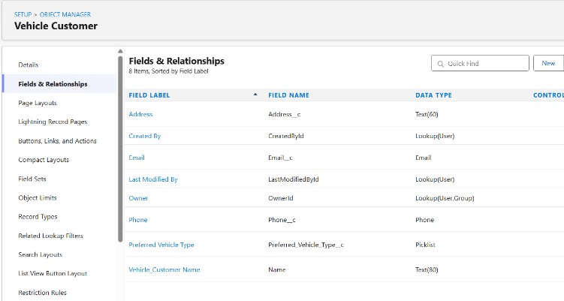
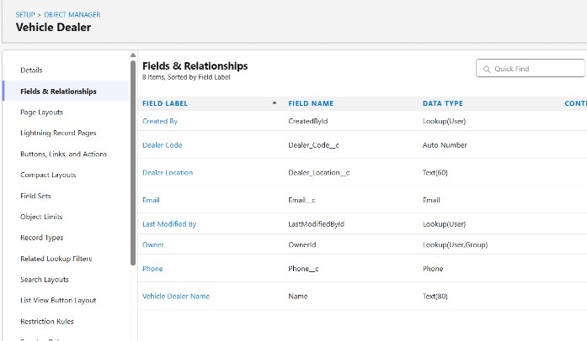 | 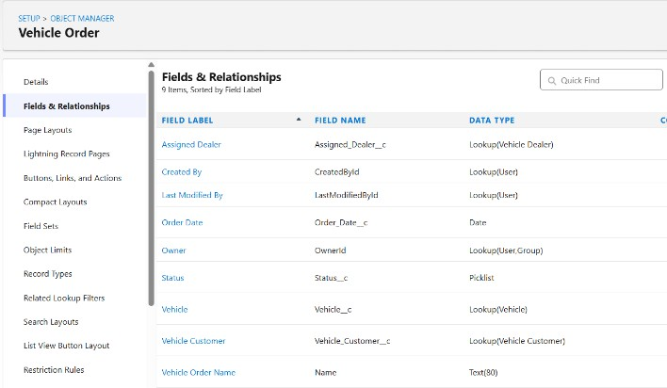

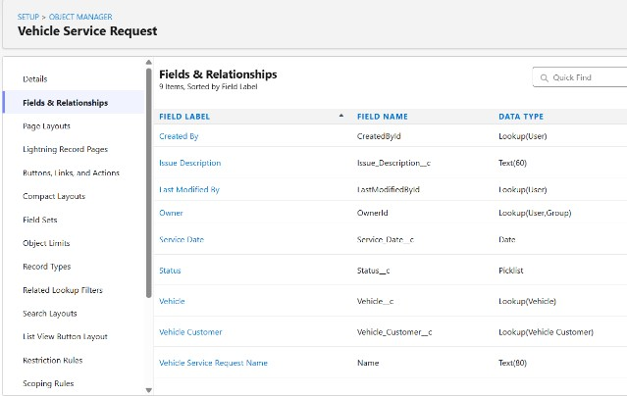 | 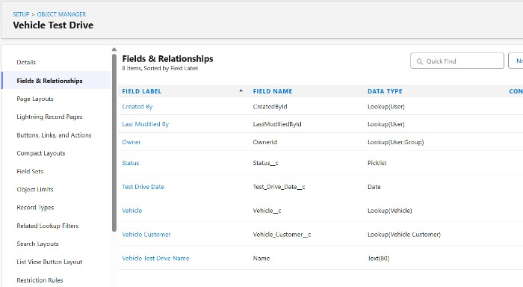
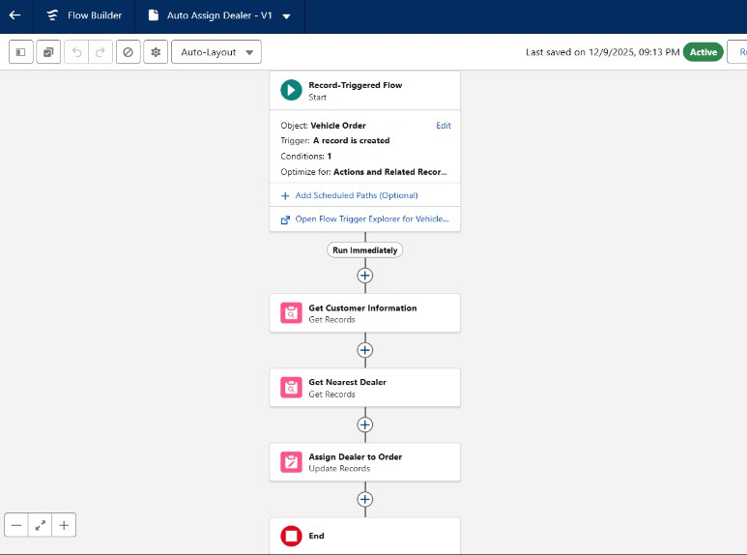
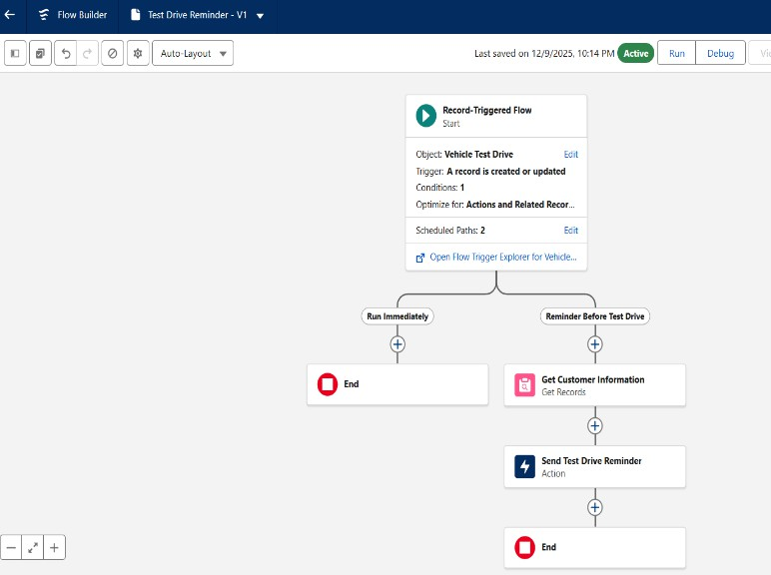

Creating Flows
Record-triggered flows were created to automate key business processes without code. For example, a flow was built to auto-assign the nearest dealer when a vehicle order is created with status Pending.
Another flow sends email reminders to customers one day before their scheduled test drive.

Steps followed:
  - Setup → Flows → New Flow → Record-Triggered Flow.

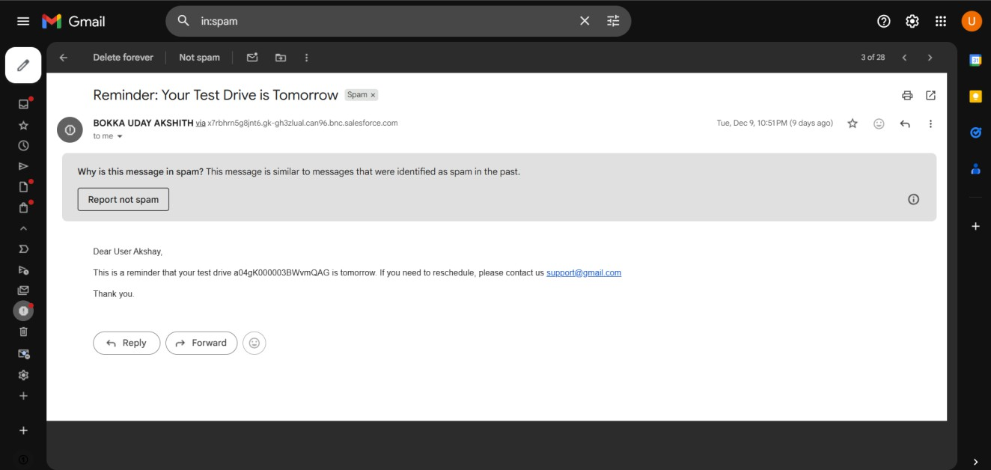

Create Apex and Trigger Batch Jobs:
Apex classes and triggers were created to enforce business logic during order processing.
  - A trigger checks vehicle stock when an order is placed and updates stock on confirmation.
  - A batch class regularly scans pending orders and updates them to Confirmed if stock becomes available.
  - A scheduled class runs the batch job daily to automate order updates.

Steps followed:
  - Developer Console → File → New → Apex Class.

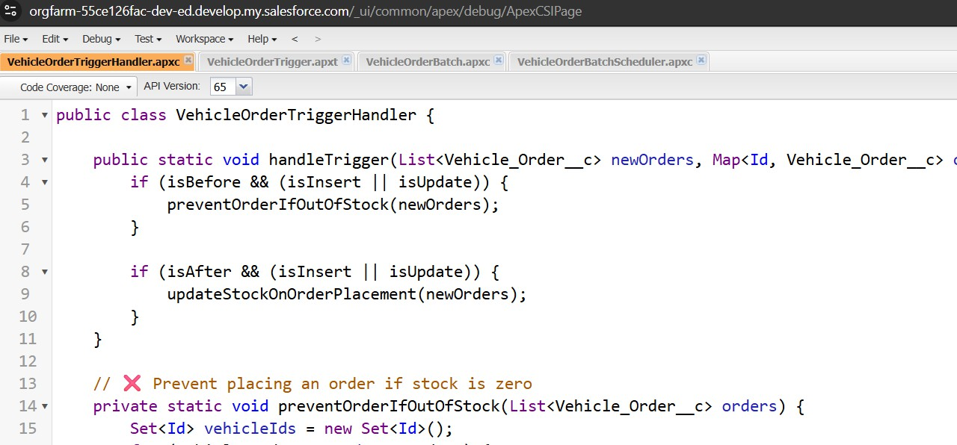

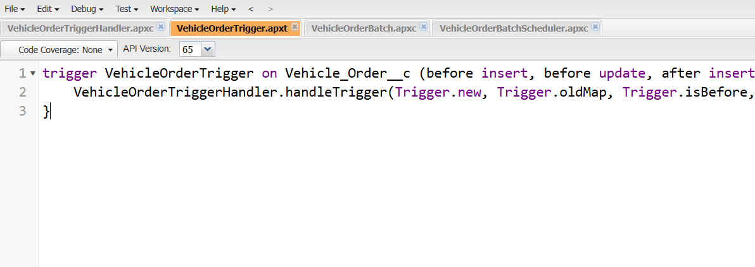
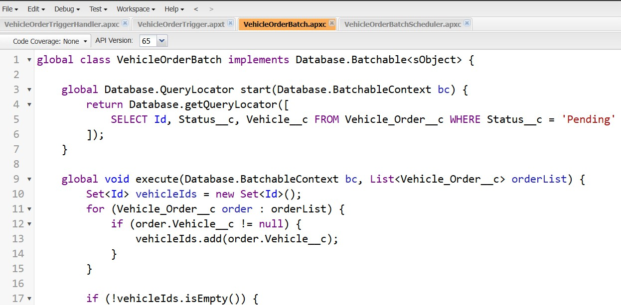
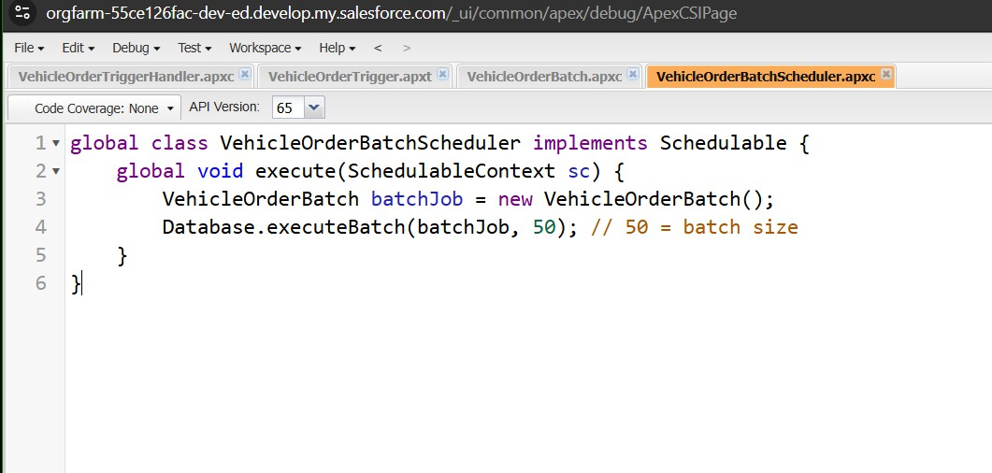

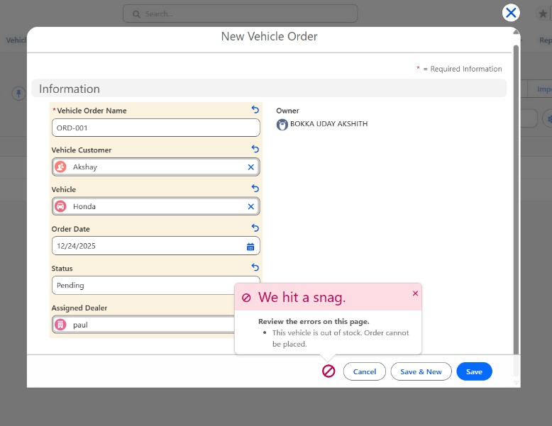

Scheduled Jobs

The Scheduled Apex Jobs page in Salesforce displays all Apex jobs that are scheduled to run automatically, such as batch jobs, schedulable classes, and queueable jobs. It provides key details like job name, type, status (Queued, Processing, Completed, Failed), submission time, next scheduled run, and the user who submitted it. From this page, administrators can monitor job progress, check for errors, and manage jobs by aborting, pausing, or deleting them when needed. This helps ensure that automated processes run smoothly and any issues can be quickly identified and resolved.

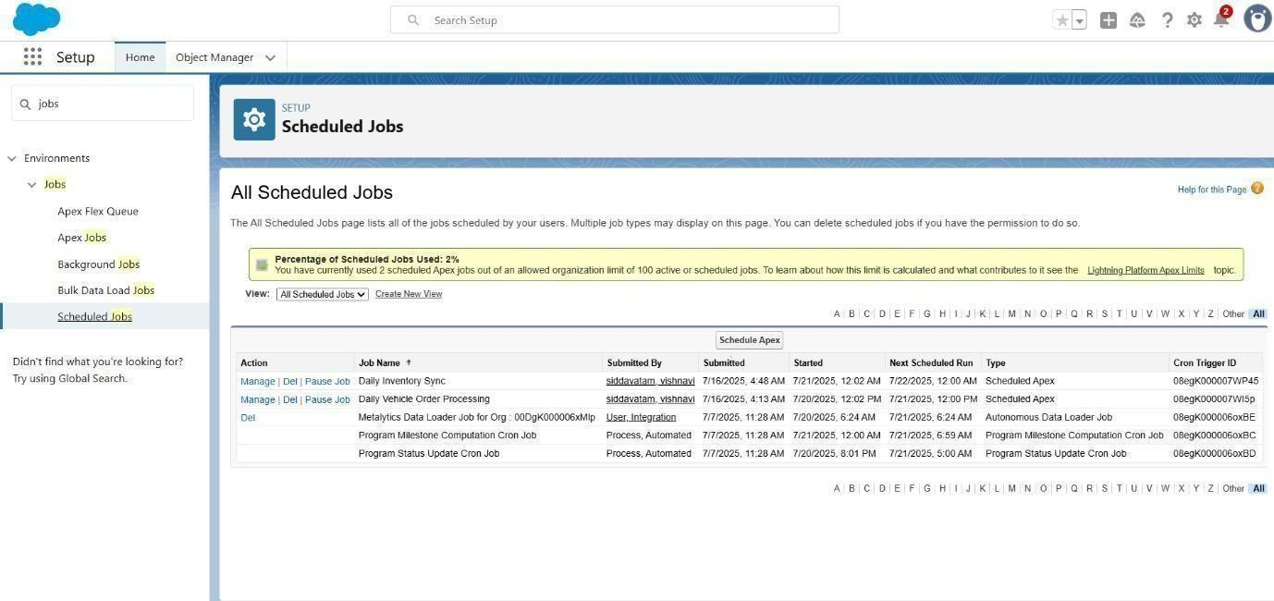

PROJECT EXPLANATION WITH REAL-WORLD EXAMPLE

Customer Registration Real-Life Example:
A customer, Elijah Mikaelson, visits the automobile showroom or website.

In Salesforce:

  - A new record is created in the Vehicle_Customerc object with his details such as Name, Phone, Email, and Address.
  - Validation Rule: Ensures the email is valid (e.g., must contain “@gmail.com”). If invalid, an error is shown. 2. Vehicle & Inventory Management

Real-Life Example:
The store admin adds cars like BMW X5, Toyota Fortuner, etc., with stock quantity (e.g., 5 BMWs and 3 Fortuners).

In Salesforce:

  - Each vehicle is stored in the Vehiclec object with details like Price, Model, and Stock Quantity.
  - Validation Rule: Prevents adding a vehicle with negative stock values. 3. Order Placement

Real-Life Example:
Elijah places an order for 1 BMW X5 (Price ₹50,00,000).

In Salesforce:

  - A new record is created in the Vehicle_Orderc object.

Apex Trigger (VehicleOrderTrigger):
    - Automatically calculates Total Amount = Price × Quantity.
    - Checks stock availability:
 If stock > 0 → Statusc = Confirmed.
 If stock = 0 → Statusc = Pending.

Inventory Update

Real-Life Example:
When Elijah’s order is confirmed, the BMW stock decreases by 1 (from 5 → 4).

In Salesforce:

  - Apex Trigger (VehicleOrderTriggerHandler):
    - Updates Vehiclec.Stock_Quantityc by subtracting the quantity ordered. o Prevents stock from going below zero. 5. Pending

→ Confirmed Orders (Stock Refill)

Real-Life Example:
If BMW stock is 0 and Elijah’s order was pending, when the admin refills 5 BMWs, the system
automatically confirms pending orders (if stock is available).

In Salesforce:

  - VehicleTrigger (After Update):
    - Detects stock refill. o Calls confirmPendingOrders() in the VehicleOrderTriggerHandler. o Updates all pending orders to Confirmed until stock runs out. 6. Scheduled Batch Processing

Real-Life Example:
At the end of each day, a batch job runs to update any remaining pending orders automatically.

In Salesforce:

  - VehicleOrderBatch & VehicleOrderBatchScheduler:
    - Confirm pending orders if stock is available. o Sends admin a log of processed orders.

Email Notifications (Flow)

Real-Life Example:
When an order is confirmed or pending, Elijah gets an email notification. In Salesforce:

Record-Triggered Flow:
    - Sends an email alert:
“Your BMW X5 order is confirmed!” or
“Your order is pending due to low stock.”

Users and Roles Real-Life Example:
  - Niklaus Mikaelson (Sales Manager) handles customer orders.
  - Kol Mikaelson (Inventory Manager) manages vehicle stock.

In Salesforce:

  - Roles and Profiles:
    - Sales Role: Access to Vehicle_Orderc and Vehicle_Customerc.
    - Inventory Role: Access to Vehiclec and stock management.

Real-Life Benefit

This system ensures:

  - No manual stock checks (triggers handle it automatically).
  - Automatic order status updates (Confirmed or Pending).
  - Smooth communication with customers via email alerts.
  - Dealer assignment (optional via Flow) ensures orders are assigned to the nearest dealer.

SCREENSHOTS
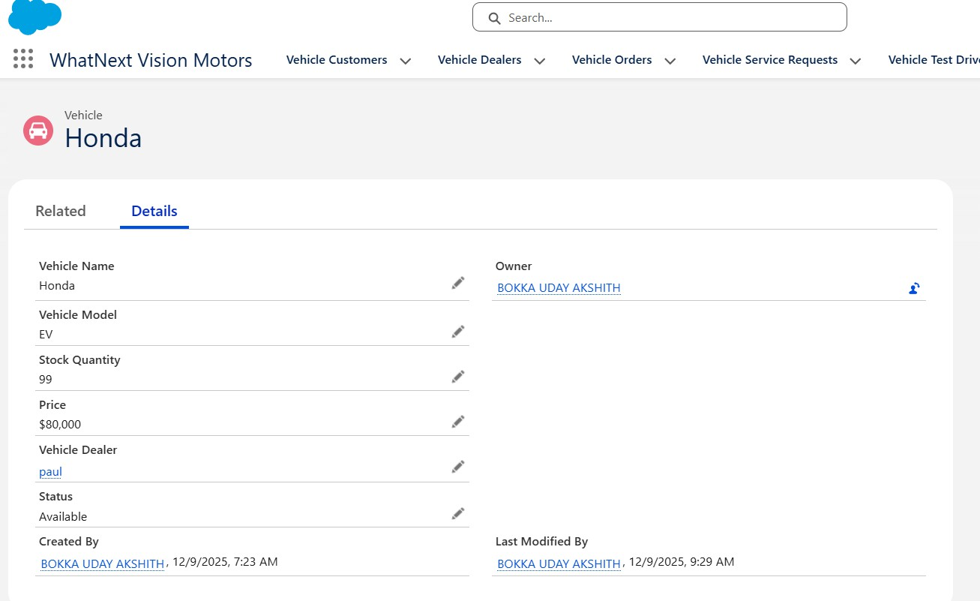
Fig: Vehicles in WhatNext Vision Motors

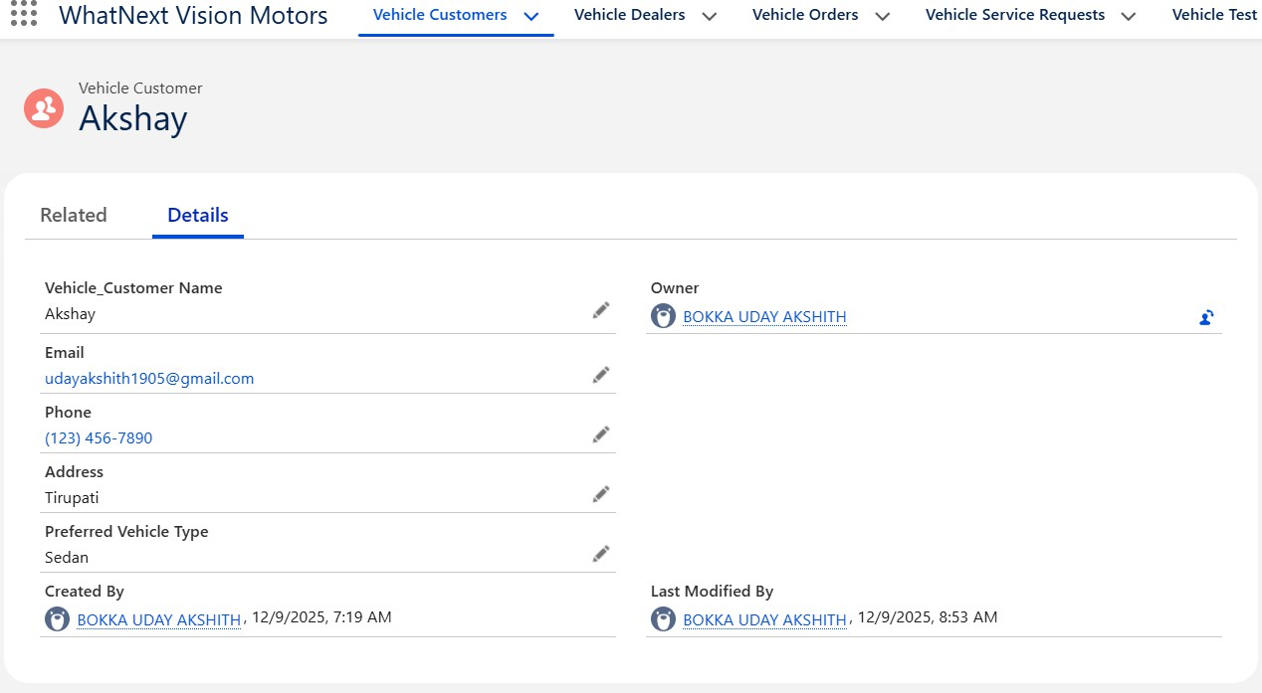

Fig: Customers in WhatNext Vision Motors

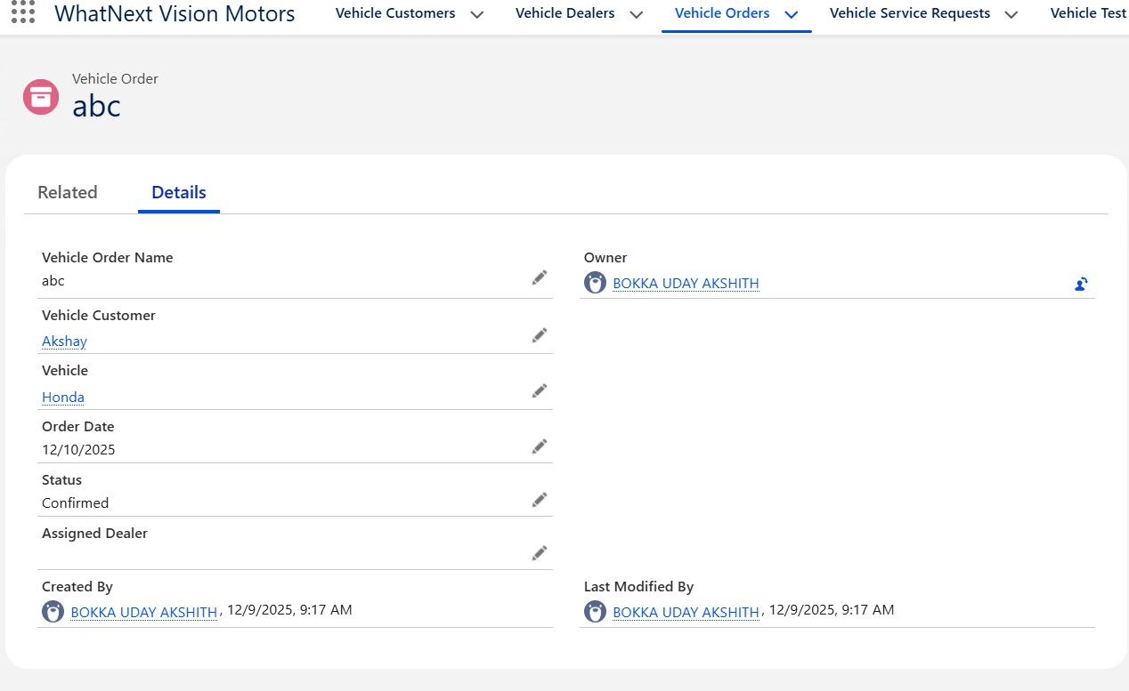
Fig: Vehicle Orders in WhatNext Vision Motors

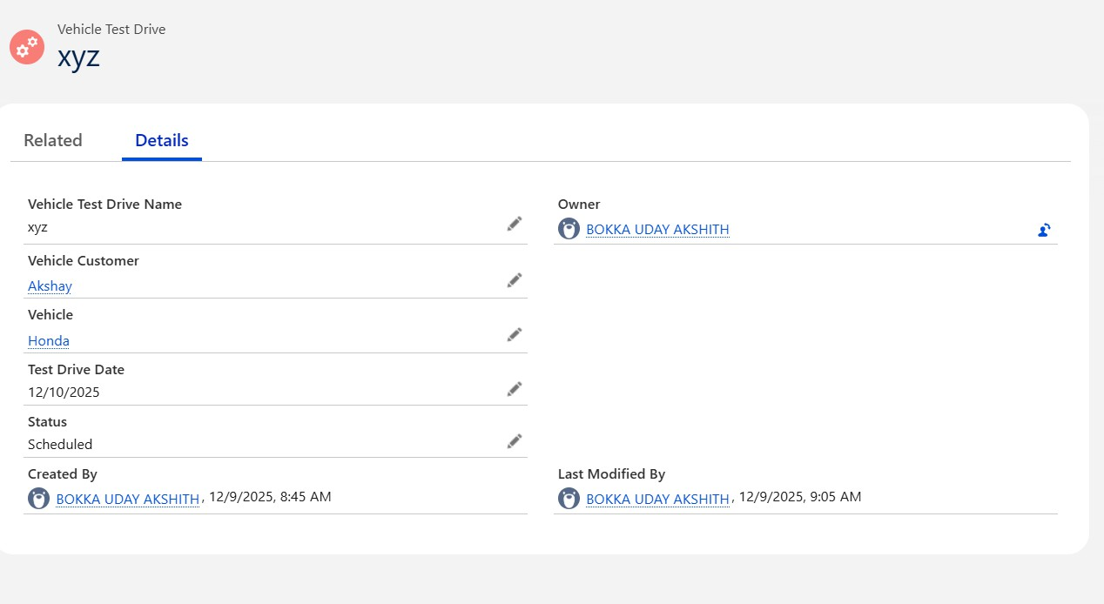

Fig: Test Drives in WhatNext Vision Motors
CONCULSION
WhatNext Vision Motors leverages Salesforce to streamline its vehicle sales and service operations. By creating custom objects, automated flows, and Apex triggers, the company ensures efficient order processing, real-time stock management, and improved customer engagement. This digital transformation enhances productivity, reduces errors, and delivers a seamless experience for both staff and customers, positioning WhatNext Vision Motors for sustained growth and success.

Future Scope

- Customer Portal Integration o Develop a Salesforce Community Portal where customers can log in to:
 View their order history and current order status.
 Check loyalty program points and rewards.
 Raise queries or service requests directly.
- Mobile App using Salesforce Mobile SDK o Build a mobile application for store staff and managers to:
 Manage inventory (add or update stock).
 Process customer orders in real-time.
 Access dashboards and order reports on the go.
- Reports & Dashboard o Create dynamic dashboards and reports in Salesforce for:
 Real-time vehicle stock levels.
 Sales trends and revenue analysis.
 Monitoring loyalty program metrics.
- AI-Powered Recommendations (Einstein AI) o Integrate

Salesforce Einstein to:
 Analyze customer purchase history.

 Provide personalized vehicle recommendations (e.g., suggest SUVs for customers buying family cars).
- WhatsApp/SMS Integration o Use Salesforce Digital Engagement
or third-party tools (like Twilio) to:
 Send instant notifications about order confirmation or pending status.
 Update customers about loyalty status or promotional offers.

TEAM MEMBERS AND ROLES:

PRANESH KUMAR M: Developer Account Creation and Activation, Lightning App, Object and Tab Creation
DINESH P L: Object Field, Tab, and Report Creation
VENKADESH P Flow and Trigger Creation
VENKATESH M: Reviews, Dashboard Creation, and Staff Management

